**Gas Leakage Monitoring and Alerting**

**System for Industries**

**TEAM MEMBER: GOKUL R ( TEAM LEADER**)

**GAYATHRI R**

**HARITHA R**

**BHARATH KRISHNAA J**

**DEPARTMENT OF ELECTRONICS AND COMMUNICATION ENGINEERING**

**TEAM ID:**

INTRODUCTION

Project Overview

Safety plays a critical role in today’s world, and certain solutions must be implemented in places of work and living. Whether it is electricity or oil and gas, working or living in hazardous conditions demands certain safety protocols. Leakage of any kind of gas has been a concern in recent years, whether it is in a residential setting, a business, a cafe, or a canteen. This project proposes developing an IoT-based gas wastage monitoring, leakage detecting, and alerting system. IoT includes broadening the Internet network past standard devices, for example, work areas, workstations, cell phones, and tablets, to any scope of the generally stupid or non-web-empowered physical device and ordinary articles. If any gas leakage is detected the admins will be notified along with the location. In the web application, admins can view the sensor parameters. As a result, a system for detecting and monitoring gas leaks is required. The system will keep an eye on fire and flame through a flame sensor. The buzzer begins to ring when a fire is detected.

Purpose

Currently, the home safety detection system plays an important role in the security of people. Since everyone from the home goes to work daily, it is impossible to check on the appliances available at home, especially LPG gas cylinder, wired circuits, Etc. In the last three years, there is a tremendous hike in the demand for liquefied petroleum gas (LPG) and natural gas. Inhaling concentrated gas can lead to asphyxia and possible death. To overcome these disasters, we designed a system for monitoring and alerting the leakage of those harmful gases. This makes the industrialists get rid of the fear of any disasters caused by the gases.

**LITERATURE SURVEY**

Existing problem

Gas leakage is nothing but the leak of any gaseous molecule from a stove, a pipeline, or cylinder, etc. This can occur either purposefully or even unintendedly. We are aware that these kinds of leaks are dangerous to our health, and when they become explosive, they could cause great danger to people, their homes, the workplace industry, and the environment. The number of sensors is unpredictable, and the positioning of equipment is improper also the affordable of the system is high and the systems sometimes cause heavy disasters.

References

**1. Internet of Things (IOT) Based Gas Leakage Monitoring and Alerting System with MQ-2 Sensor by Rohan Chandra Pandey , Manish Verma , Lumesh Kumar Sahu.**

Safety plays a major role in today’s world and it is necessary that good safety systems are to be implemented in places of education and work. This work modifies the existing safety model installed in industries and this system also be used in homes and offices. The work's main objective is to design a microcontroller-based toxic gas detecting and alerting system. The hazardous gases like LPG and propane were sensed and displayed and notified each and every second in the LCD display.

**2.GAS LEAKAGE DETECTION AND SMART ALERTING SYSTEM USING IOT by Shital Imade, Priyanka Rajmanes, Aishwarya Gavali , Prof. V. N. Nayakwadi**

The Internet of Things aims towards making life simpler by automating every small task around us. As much as IoT helps in automating tasks, the benefits of IoT can also be extended to enhancing the existing safety standards. Safety, the elementary concern of any project, has not been left untouched by IoT. Gas Leakages in open or closed areas can prove to be dangerous and lethal. The traditional Gas Leakage Detector Systems though have great precision, fail to acknowledge a few factors in the field of alerting people about the leakage.

**3.Gas Leakage Detection and Alert System using IoT by Sayali Joshi, Shital Munjal, Prof. Uma B. Karanja.**

The Internet of things (IoT) is the system of gadgets, vehicles, and home machines that contain hardware, programming, actuators, and network which enables these things to the interface, collaborate and trade information. The meaning of the Internet of things has advanced because of the union of numerous innovations, ongoing examination, AI, ware sensors, and implanted frameworks. Conventional fields of installed frameworks, remote sensor systems, control frameworks computerization (Counting home and building mechanization), and others all add to empowering the Internet of things. A gas spill alludes to a hole of petroleum gas or a different vaporous item from a pipeline or other regulation into any territory where the gas ought not to be available.

Problem Statement Definition

Homes and Industrial fires have taken a growing toll on lives and property in recent years. Most gasses used for industrial activities are highly inflammable and can burn even at some distance from the source of leakage.

|  |  |  |  |  |  |
| --- | --- | --- | --- | --- | --- |
| **Problem**  **Statement**  **(PS)** | **I am**  **(Customer)** | **We are trying to** | **But** | **Because** | **Which makes me feel** |
| PS-1 | Industrialist | Monitor gas leakage in the industry and domestic households | I have no efficient system for monitoring | High cost and complicated ed process of Installing | Dissatisfied |
| PS-2 | Chemist | Control the gas leakage due to preparation | Also, the installation process is too complicated | The number of sensors is unpredictable, and the positioning of equipment is improper | Frustrated |

**IDEATION & PROPOSED SOLUTION**

Empathy Map Canvas

Ideation & Brainstorming

The Internet of things (IoT) is the system of gadgets, vehicles, and home machines that contain hardware, programming, actuators, and network which enables these things to the interface, collaborate and trade information. IoT includes broadening Internet networks past standard devices, for example, work areas, workstations, cell phones, and tablets, to any scope of the generally stupid or non-web-empowered physical devices and ordinary articles. Installed with innovation, these gadgets can convey and connect over the Internet, and they can be remotely observed and controlled. The meaning of the Internet of things has advanced because of the union of numerous innovations, ongoing examination, AI, ware sensors, and implanted frameworks.

Proposed Solution

|  |  |  |
| --- | --- | --- |
| S.NO | PARAMETER | DESCRIPTION |
| 1. | Problem Statement (Problem to be solved) | Homes and Industrial fires have taken a growing toll on lives and property in recent years. Most gasses used for industrial activities are highly inflammable and can burn even at some distance from the source of leakage. Most fire accidents are caused because of a poor-quality rubber tube or when the regulator is not turned off. The supply of gas from the regulator to the burner is on even after the regulator is switched off. By accident, if the knob is turned on, it results in gas leaks. Safety plays a major role in today’s world, and it is necessary that good safety systems are implemented in places of education and work. |
| 2. | Idea / Solution description | This project detects gas leakage by using various sensors. If the gas leakage level is above the threshold level, it sends the alert message through SMS to the user by using the GSM module and buzzing the alarm. |
| 3. | Novelty / Uniqueness | The system provides constant monitoring and detection of gas leakage along with storage of data in the database for predictions and analysis. We use location tagging and alert service so that the admin and fire department team will be notified the exact location. |
| 4. | Social Impact / Customer Satisfaction | By implementing real-time gas leak detection, industries can monitor their environmental performance, ensure better occupational health, and eliminate potential hazards. Also, early detection of gas leaks can trigger concerned engineers to curtail the spread and keep a safe environment for better health and safety. |
| 5. | Business Model (Revenue Model) | The project is made compact, cost  efficient and easily installable so that all industries from small-scale to large scale will be able to afford the model |
| 6. | Scalability of the Solution | The model is very simple and easy to maintain and cost-efficient. It has the capability to work for a long period of time. As technology evolves, this project can be made even more simpler. |

Problem Solution fit

**REQUIREMENT ANALYSIS**

Functional requirement



**Non-Functional requirements**

**Data Gathering:**

Using multiple sensors, we are going to gather the necessary data.

**Data Store:**

Collected data is stored in Cloud and Necessary databases.

**Data Analysis:**

Data from the store must be analyzed for raising alerts in case of necessity.

**Data Monitoring:**

Gathered data must be displayed to the user for monitoring

**PROJECT DESIGN**

Data Flow Diagrams

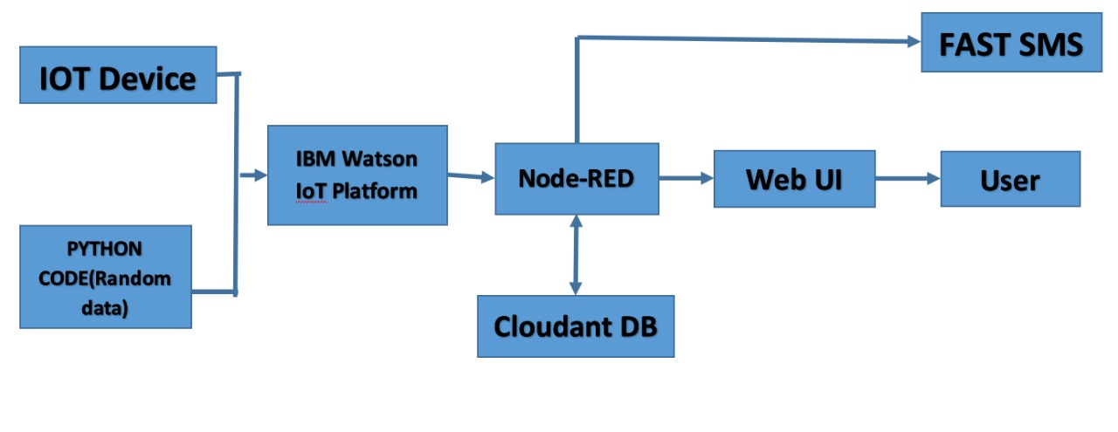

**Solution & Technical Architecture**

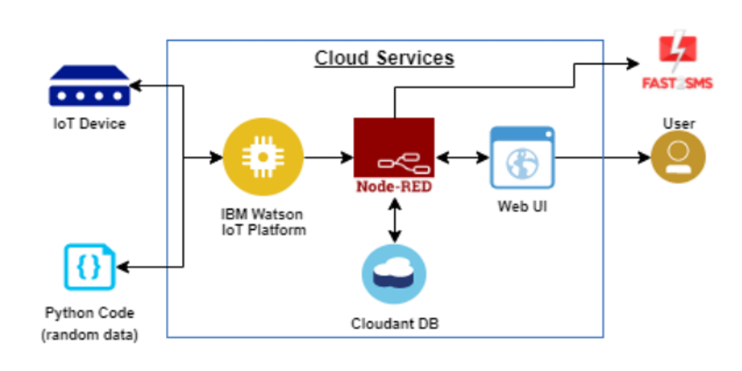

**User Stories**

The system can be taken as a small attempt in connecting the existing primary gas detection methods to a mobile platform integrated with IoT platforms. The gases are sensed in an area of a 1m radius of the rover, and the sensor output data are continuously transferred to the local server. The accuracy of sensors is not up to the mark thus stray gases are also detected which creates an amount of error in the outputs of the sensors, especially in the case of methane. Further, the availability and storage of toxic gases like hydrogen sulfide also create problems for testing the assembled hardware. As the system operates outside the pipeline, the complication of system maintenance and material selection of the system in case of corrosive gases is reduced. Thus, the system at this stage can only be used as a primary indicator of leakage inside a plant.

**PROJECT PLANNING & SCHEDULING**

Sprint Planning & Estimation

* SPRINT PLAN
* ANALYZE THE PROBLEM
* PREPARE An ABSTRACT, PROBLEM STATEMENT
* LIST A REQUIRED OBJECT NEEDED
* CREATE A PROGRAM CODE AND RUN IT
* MAKE A PROTOTYPE TO IMPLEMENT
* TEST WITH THE CREATED CODE AND CHECK THE DESIGNED PROTOTYPE IS

**Sprint Delivery Schedule**

• Sprint 1

• Sprint 2

• Sprint 3

• Sprint 4

We are Developing the code in this Schedule.

Reports from JIRA

Reports From JIR Report of Zoho project management software

**CODING & SOLUTIONING**

**Feature 1**

If any gas leakage is detected by the sensor, it sends a signal to the entire module and the Buzzer added in our system gives s signal as an alarm sound to alert people in the place. Code for this is given below in 13. Appendix.

CIRCUIT DIAGRAM

**Components**

The design of a sensor-based automatic gas leakage detector with an alert and control system. The components are

|  |  |  |
| --- | --- | --- |
| **S. No.** | **Name of the Component** | **Quantity** |
| 1. | Arduino UNO R3 | 1 |
| 2. | Breadboard | 1 |
| 3. | LED | 2 |
| 4. | Resistor | 5 |
| 5. | Piezo | 1 |
| 6. | Gas Sensor | 1 |
| 7. | LCD (16x2) | 1 |

**TESTING**

As all connections are made and verified, the entire module is simulated to check its working. The sensor keeps on detecting any gas leakage is there. If there is no leakage happens no alert signals are sent.

**ADVANTAGES**

* Detect the concentration of the gases
* The sensor-enabled solution helps prevent the high risk of gas explosions and affecting any casualties within and outside the premises.
* Get real-time alerts about the gaseous presence in the atmosphere
* Prevent fire hazards and explosions.
* Supervise gas concentration levels
* Ensure worker’s health

**DISADVANTAGES**

* Only one gas can be measured with each instrument.
* When heavy dust, steam, or fog blocks the laser beam, the system will not be able to take measurement

**CONCLUSION**

After this project performance can conclude that the detection of the LPG gas leakage is incredible in the project system. Applicable usefully for industrial and domestic purposes. In dangerous situations, we can save the life by using this system. An alert is indicated by the GSM module. Hence, gas leakage detection is essential to prevent accidents and save human lives. This paper presented an LPG leakage detection and alert system. This system triggers a buzzer and notification to alert people when gas leakage is detected. This system is basic yet reliable.

**FUTURE SCOPE**

Major cities in India are pushing the Smart Home application, and the gas monitoring system is a part of the Smart Home application. Enhancing Industrial Safety using IoT. This system can be implemented in Industries, Hotels, and wherever the gas cylinders are used. This system can be used in industries involving applications such as Furnaces, Boilers, Gas welding, Gas cutting, Steel Plants, Metallurgical industries, Food processing Industries, Glass Industries, Plastic industries, Pharmaceuticals, and Aerosol manufacturing. Our system uses the gas sensor to detect any gas leakages. The gas sensor sends out a signal to the microcontroller as soon as it encounters a gas leakage. The microcontroller processes this signal, and a message is displayed on the LCD to alert the user.

**APPENDIX:**

**Source Code:**

#include <LiquidCrystal.h>

LiquidCrystal lcd(6, 7, 8, 9, 10, 11);

float gasPin = A0;

float gasLevel;

int ledPin = 2;

int buttonPin = 3;

int buzzPin = 4;

int buttonState;

int fan = 5;

void setup(){

pinMode(ledPin, OUTPUT);

pinMode(buttonPin, INPUT);

pinMode(gasPin,INPUT);

pinMode(fan,OUTPUT);

Serial.begin(9600);

lcd.begin(16, 2);

lcd.setCursor(0,0);

lcd.print(" Welcome");

lcd.setCursor(0,2);

lcd.print("GAS LEAKAGE SYSTEM");

delay(500);

lcd.clear();

}

void loop(){

// Read the value from gas sensor and button

gasLevel = analogRead(gasPin);

buttonState = digitalRead(buttonPin);

// call the function for gas detection and button work

gasDetected(gasLevel);

buzzer(gasLevel);

exhaustFanOn(buttonState);

}

// Gas Leakage Detection & Automatic Alarm and Fan ON

void gasDetected(float gasLevel){

if(gasLevel >= 300){

digitalWrite(buzzPin,HIGH);

digitalWrite(ledPin,HIGH);

digitalWrite(fan,HIGH);

lcd.setCursor(0,0);

lcd.print("GAS:");

lcd.print(gasLevel);

lcd.setCursor(0,2);

lcd.print("FAN ON");

delay(1000);

lcd.clear();

}else{

digitalWrite(ledPin,LOW);

digitalWrite(buzzPin,LOW);

digitalWrite(fan,LOW);

lcd.setCursor(0,0);

lcd.print("GAS:");

lcd.print(gasLevel);

lcd.setCursor(0,2);

lcd.print("FAN OFF");

delay(1000);

lcd.clear();

}

}

//BUZZER

void buzzer(float gasLevel){

if(gasLevel>=300)

{

for(int i=0; i<=30; i=i+10)

{

tone(4,i);

delay(400);

noTone(4);

delay(400);

}

}

}

// Manually Exhaust FAN ON

void exhaustFanOn(int buttonState){

if(buttonState == HIGH){

digitalWrite(fan,HIGH);

lcd.setCursor(0,0);

lcd.print("Button State:");

lcd.print(buttonState);

lcd.setCursor(0,2);

lcd.print("FAN ON");

delay(10000);

lcd.clear();

}

}

GitHub & Project Demo Link

GitHub Link: <https://github.com/IBM-EPBL/IBM-Project-12029-1659367196>

Simulation Link:

https://drive.google.com/file/d/1R9s_UcP0c5juxWt1Gn3KcWMeCGkPWBJ1/view?usp=share_link&authuser=1